NETWORKING AND SYSTEM ADMINISTRATION LAB

**COMPUTER HARDWARE**

Want to know what hardware is in your computer? Become a computer pro with our quick guide to these essential components and their roles.

Quite simply, computer hardware is the physical components that a computer system requires to function. It encompasses everything with a circuit board that operates within a PC or laptop; including the motherboard, graphics card, CPU (Central Processing Unit), ventilation fans, webcam, power supply, and so on.

Although the design of hardware differs between desktop PCs and laptops due to their differences in size, the same core components will be found in both. Without hardware, there would be no way of running the essential software that makes computers so useful. Software is defined as the virtual programs that run on your computer; that is, operating system, internet browser, word-processing documents, etc.

Although a computer can function only when both hardware and software are working together, the speed of a system will largely rely on the hardware used.

When building up a new computer, or simply replacing old parts, you may need to know the specific hardware in your computer. The purpose of this guide is therefore to help you understand the inner-workings of your computer.

## **MOTHERBOARD**

The motherboard is at the center of what makes a PC work. It houses the CPU and is a hub that all other hardware runs through. The motherboard acts as a brain; allocating power where it’s needed, communicating with and coordinating across all other components – making it one of the most important pieces of hardware in a computer.

When choosing a motherboard, it’s important to check what hardware ports the motherboard supplies. It’s vital to check how many USB ports, and what grade (USB 2.0, 3.0, 3.1) they are, as well as what display ports are used (HDMI, DVI, RGB) and how many of each there are. The ports on the motherboard will also help you define what other hardware will be compatible with your computer, such as what type of RAM and graphics card you can use.

Although the motherboard is just one piece of circuitry, it is home to another one of the most important pieces of hardware: the processor.

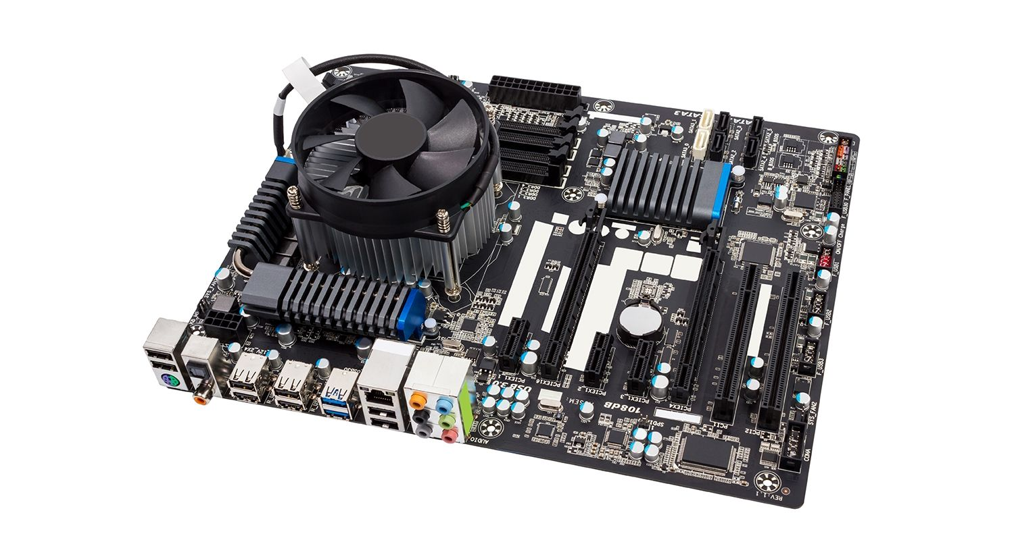

**RAM MODULE**

In computing a **memory module** or **RAM (**[**random-access memory**](https://en.wikipedia.org/wiki/Random-access_memory)**) stick** is a printed circuit board on which memory integrated circuit are mounted. Memory modules permit easy installation and replacement in electronic systems, especially computers such as [personal computers](https://en.wikipedia.org/wiki/Personal_computer), [workstations](https://en.wikipedia.org/wiki/Workstation), and [servers](https://en.wikipedia.org/wiki/Server_(computing)). The first memory modules were proprietary designs that were specific to a model of computer from a specific manufacturer. Later, memory modules were standardized by organizations such as [JEDEC](https://en.wikipedia.org/wiki/JEDEC) and could be used in any system designed to use them.

Types of memory module include:

* [TransFlash Memory Module](https://en.wikipedia.org/wiki/TransFlash_Memory_Module)
* [SIMM](https://en.wikipedia.org/wiki/SIMM), a single in-line memory module
* [DIMM](https://en.wikipedia.org/wiki/DIMM), dual in-line memory module
  + [Rambus](https://en.wikipedia.org/wiki/Rambus) memory modules are a subset of DIMMs, but are normally referred to as RIMMs
  + [SO-DIMM](https://en.wikipedia.org/wiki/SO-DIMM), small outline DIMM, a smaller version of the DIMM, used in laptops

Distinguishing characteristics of computer memory modules include voltage, capacity, speed (i.e., [bit rate](https://en.wikipedia.org/wiki/Bit_rate)), and [form factor](https://en.wikipedia.org/wiki/Computer_form_factor). For economic reasons, the large (main) memories found in personal computers, workstations, and non-handheld game-consoles (such as PlayStation and Xbox) normally consist of dynamic RAM (DRAM). Other parts of the computer, such as [cache memories](https://en.wikipedia.org/wiki/Cache_memory) normally use [static RAM](https://en.wikipedia.org/wiki/Static_RAM) ([SRAM](https://en.wikipedia.org/wiki/Static_random_access_memory)). Small amounts of SRAM are sometimes used in the same package as DRAM. However, since SRAM has high leakage power and low density, [die-stacked](https://en.wikipedia.org/wiki/Three-dimensional_integrated_circuit) DRAM has recently been used for designing multi-megabyte sized processor caches. Physically, most DRAM is [packaged](https://en.wikipedia.org/wiki/Integrated_circuit_packaging) in black epoxy resin.

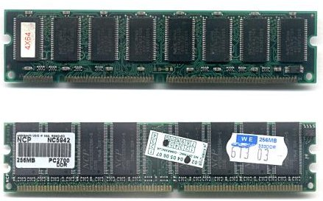

**Daughter card**

A daughterboard (or *daughter board*, *daughter card*, or *daughtercard*) is a circuit board that plugs into and extends the circuitry of another circuit board. The other circuit board may be the computer's main board (its motherboard) or it may be another board or card that is already in the computer, often a sound card. The term is commonly used by manufacturers of wavetable daughterboards that attach to existing sound cards.

A mezzanine card is a kind of daughterboard that is installed in the same plane as but on a second level above the motherboard.

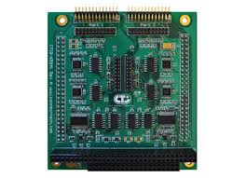

**BUS SLOT**

Alternatively known as a **bus slot** or **expansion port**, an **expansion slot** is a connection or port inside a [computer](https://www.computerhope.com/jargon/c/computer.htm) on the [motherboard](https://www.computerhope.com/jargon/m/mothboar.htm) or [riser card](https://www.computerhope.com/jargon/r/risecard.htm). It provides an installation point for a hardware expansion card to be connected. For example, if you wanted to install a new video card in the computer, you'd purchase a video expansion card and install that card into the compatible expansion slot.

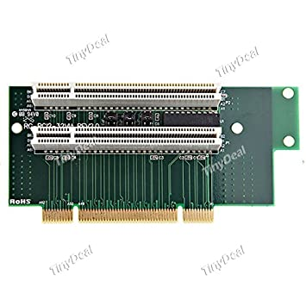

## **Computer expansion slots**

Below is a listing of expansion slots commonly found in a computer and the devices associated with those slots. Clicking any of the links below provide you with additional details.

* [**AGP**](https://www.computerhope.com/jargon/a/agp.htm) - [Video card](https://www.computerhope.com/jargon/v/video-card.htm).
* [**AMR**](https://www.computerhope.com/jargon/a/amr.htm) - [Modem](https://www.computerhope.com/jargon/m/modem.htm), [sound card](https://www.computerhope.com/jargon/s/souncard.htm).
* [**CNR**](https://www.computerhope.com/jargon/c/cnr.htm) - Modem, [network card](https://www.computerhope.com/jargon/n/nic.htm), sound card.
* [**EISA**](https://www.computerhope.com/jargon/e/eisa.htm) - [SCSI](https://www.computerhope.com/jargon/s/scsi.htm), network card, video card.
* [**ISA**](https://www.computerhope.com/jargon/i/isa.htm) - Network card, sound card, video card.
* [**PCI**](https://www.computerhope.com/jargon/p/pci.htm) - Network card, SCSI, sound card, video card.
* [**PCI Express**](https://www.computerhope.com/jargon/p/pciexpre.htm) - Video card, modem, sound card, network card.
* [**VESA**](https://www.computerhope.com/jargon/v/vesa.htm) - Video card.

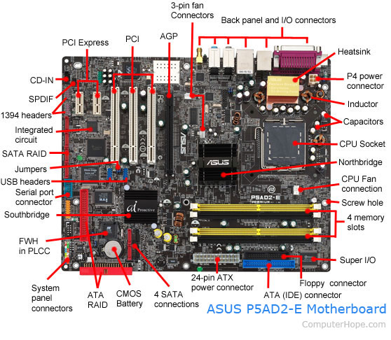

**SMPS**

The full form of SMPS is **Switched Mode Power Supply** also known as **Switching Mode Power Supply**. SMPS is an electronic power supply system that makes use of a switching regulator to transfer electrical power effectively. It is a PSU (power supply unit) and is usually used in computers to change the voltage to the appropriate range for the computer.

An SMPS adjusts output voltage and current between different electrical configurations by switching the basics of typically lossless storage such as capacitors and inductors. Ideal switching concepts determined by transistors controlled outside of their active state that have no resistance when ‘on’ and carry no current when ‘off.’ It is the idea why switches with an ideal function will operate with 100 per cent output, that is, all input energy is provided to the load; no power is wasted as dissipated heating. In fact, such ideal systems do not exist, which is why a switching power source can not be 100 per cent proficient, but it is still a vital improvement in effectiveness over a linear regulator.

## **Working principles of SMPS**

In the SMPS device, the switching regulators are used which switches on and off the load current to maintain and regulate the voltage output. Suitable power generation for a system is the mean voltage between off and on. Unlike the linear power supply, the SMPS carry transistor switches among low dissipation, full-on and full-off phase, and spend much less time in high dissipation cycles, which decreases depleted strength.

### **Benefits of SMPS**

* The switch-mode power source is small in scale.
* The SMPS is very lightweight.
* SMPS power consumption is typically 60 to 70 per cent, which is ideal for use.
* SMPS is strongly anti-interference.
* The SMPS production range is large.

### **Limitations of SMPS**

* The complexity of SMPS is very large.
* The production reflection is high and its control is weak in the case of SMPS.
* Use of SMPS can only be a step-down regulator.
* In SMPS, the voltage output is just one.

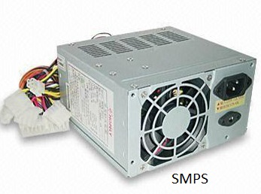

## **Internal Storage Devices**

Some storage devices are classed as 'internal' which means they are inside the computer case.

Most computers have some form of internal storage. The most common type of internal storage is the hard disk.

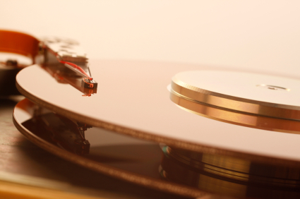

At the most basic level, internal storage is needed to hold the operating system so that the computer is able to access the input and output devices.

It will also be used to store the applications software that you use and more than likely, the original copies of your data files.

Internal storage allows the data and applications to be loaded very rapidly into memory, ready for use. The data can be accessed much faster than data which is stored on an external storage device. This is because internal storage devices are connected directly to the motherboard and its data bus whereas external devices are connected through a hardware interface such as USB, which means they are considerably slower to access.

Internal storage also means that if the computer is moved around, it will still retain its most commonly used data.

The main disadvantage of internal storage is that when the hard disk fails (and it will), all the data and applications may be lost.

This can be avoided to some extent by using more than one hard disk within the machine. Each hard disk has a copy of all the data, so if one fails the other can carry on. This is called a RAID array. An alternative is to use external drives for backup.

**Ports and Interfaces**

The Motherboard of a computer has many I/O sockets that are connected to the ports and interfaces found on the rear side of a computer (Figure 3.13). The external devices can be connected to the ports and interfaces. The various types of ports are given below:

**Serial Port:**To connect the externaldevices, found in old computers.

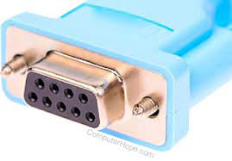

**Parallel Port:**To connect the printers,found in old computers.

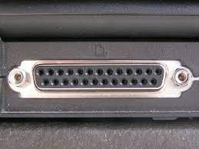

**USB Ports:**To connect external deviceslike cameras, scanners, mobile phones, external hard disks and printers to the computer.

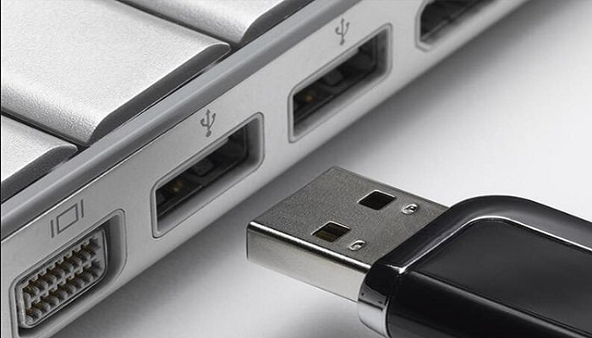

**USB 3.0**is the third major version of theUniversal Serial Bus (USB) standard to connect computers with other electronic gadgets as shown in Figure 3.13. USB 3.0 can transfer data up to 5 Giga byte/second. USB3.1 and USB 3.2 are also released.

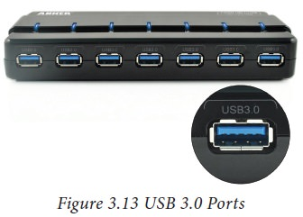

. **VGA Connector:**To connect a monitor orany display device like LCD projector

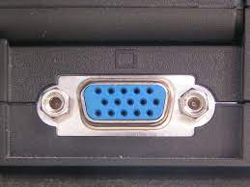

**Audio Plugs:**To connect sound speakers,microphone and headphones.

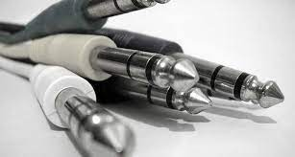

**PS/2 Port:**To connect mouse andkeyboard to PC.

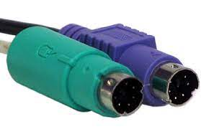

**SCSI Port:**To connect the hard diskdrives and network connectors.

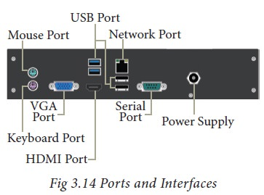

## High Definition Multimedia Interface (HDMI)

High-Definition Multimedia Interface is an audio/video interface which transfers the uncompressed video and audio data from a video controller, to a compatible computer monitor, LCD projector, digital television etc.

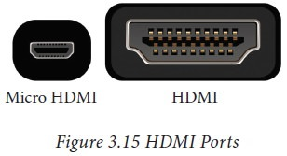

**SPECIFICATION OF DESKTOP AND SERVER CLASS COMPUTERS**

Here is a sample desktop computer specification if you are searching for a good desktop computer to buy. I have listed the most component features you should check when you buy desktop computer.

Actually, the intended usage of a computer should be your first step to answer. Why are you going to buy? What are you going to do with it? I say this because you don’t have to buy a high-end pc for tasks such as word processing, spreadsheet, web browsing or e-mail.

If you do have enough budgets, go for it. For the future it will serve you well for graphical and design works too.

This is a typical desktop computer specification, this doesn’t mean you should buy this computer. It is just a guide to help you.

|  |  |
| --- | --- |
| Component | Specification |
| Processor: | 10th or 11th Gen Intel Core i5, i7 or i9 Processor, or Apple M1 Processor (CPU) |
| Operating System: | Microsoft Windows 10 Home, Pro, Enterprise or Education version *or* macOS 10.15.X “Catalina” or 11.X “Big Sur.” |
| Memory (RAM): | 8-16 GB of RAM |
| Storage: | 240 GB solid state drive, or larger. |
| Video/Graphics: | Integrated or Discrete graphics processor capable of 1440 X 900 resolution, or better (1920 X 1080 *or* 1200 ideal). |
| Monitor: | for notebook: 13″ – 17″ display for desktop: 19″ – 27″ widescreen flat-panel display |
| Mouse: | Built-in or external trackpad, wireless and/or USB, 2-button, optical mouse |
| Sound: | Sound card or built-in audio, and speakers |
| Headphones: | Headphones or Earbuds, with Built-in Microphone |
| Webcam: | Either external USB device or built-in |
| Network: | 802.11ac Wi-Fi capability. |

*Intel i5 & i7*

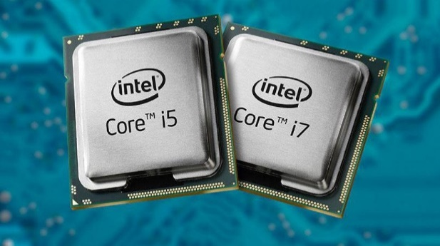

*Ryzen*

